**Accounting** is the process of measuring and recording the financial value of the assets and liabilities of a business and monitoring these values as they change with the passage of time.  When we refer to a **business** we could be referring to an individual, a company or any other entity for which accounting records are to be kept (for example a church, club or other non-profit organisation.)

The **assets** of a business are those things that belong to the business that have a positive financial value i.e. items that could be sold by the business in exchange for money.  Examples of assets include land, buildings, vehicles, stock, equipment, rare gold coins, bank accounts with positive balances and money owed to the business by its debtors.

The **liabilities** of a business are those things that belong to the business but unlike assets have a negative financial value i.e. items that will require the payment of money by the business at some point in the future.  Examples of liabilities include unpaid bills, unpaid taxes, unpaid wages, rusty motor vehicles, stock that has passed its use-by date, overdrawn bank accounts and money owed by the business to its creditors.

The **equity** of a business is defined as the value of the assets minus the value of the liabilities.  In other words the equity is the financial value that would be left if all the assets were sold and the money from the sale was used to pay off all the liabilities.  Another way of expressing this is to say that the equity is the amount of money that would be released if the business was to be wound up.

The assets, liabilities and equity of a business are all financial measurements that relate to a particular point in time.  The financial statement that is used to present this information is known as the **balance sheet**.  The balance sheet is a statement of the assets, liabilities and equity of a business as they exist at a particular point in time.

The relationship between the assets, the liabilities and the equity can be represented algebraically by what is commonly known as the **accounting equation**.  If we use the letter A to represent the assets, the letter L to represent the liabilities and the letter P to represent the equity then the accounting equation is

P = A - L

This equation states that the equity is the value of the assets minus the value of the liabilities.  This equation is more commonly written as

A = L + P

This equation states that the value of the assets is equal to the value of the liabilities plus the equity.  This is just another way of saying the same thing.  Because the equity is defined as the value of the assets minus the value of the liabilities then this equation is always true by definition.

A balance sheet is commonly divided into two sections.  One section shows the value of the assets and the other section shows the value of the liabilities and the equity.  Each section will be broken down into more or less detail depending on the intended use of the balance sheet.  Because the accounting equation is always true the totals of each of the two sections of the balance sheet should always be the same i.e. the balance sheet should always be in balance.

The financial measurements we have looked at so far are used to describe the financial position of a business at a particular point in time.  For this reason the balance sheet is also known as the **statement of financial position**.  It presents a summary of the business' financial position at a particular point in time.  However in order to gain a complete financial picture of a business we need to recognise that the financial position of the business is undergoing constant change.

As a business engages in various commercial activities such as buying, selling, manufacturing, maintaining equipment, paying rent and other expenses, borrowing, lending or investing then the value of the assets, liabilities and equity will change and these changes will have an effect on the balance sheet.  The only thing we can be sure about at any point in time is that the accounting equation A = L + P will always apply.  In other words even though the balance sheet is always changing from day to day we can be certain that it will always balance or should do so if it has been prepared correctly.

Recognising that the financial position of a business is constantly changing leads us to the definition of two additional financial measurements that relate to a period of time (unlike assets, liabilities and equity that relate to a particular point in time.)

The **income** of a business is the sum of those things that increase the value of the assets without any corresponding increase in the liabilities or any new investment by the owners of the business.  Examples include revenue from the sale of goods, equipment or services supplied, rent or interest received and capital gains.

The **expenses** of a business are those things that reduce the value of the assets without any corresponding reduction in the liabilities or any capital drawings by the owners.  Examples include the cost of stock and raw materials, rent or interest paid, electricity bills, telephone, wages, taxes, dividends, depreciation and donations to charity.

The income and expenses of a business are financial measurements that relate to a specified period of time rather than a specific point in time.  The financial statement that is used to present this information is known as the **income statement**.  The income statement is a statement of the income and expenses of a business as they occur during a specific period.

If we use the letter I to represent the income over a specified period of time and the letter E to represent the expenses over that same period we can represent the relationship between the assets, the liabilities, the equity, the income and the expenses by using a modified form of the accounting equation as follows

A = L + P + (I - E)

This equation states that the value of the assets is equal to the value of the liabilities plus the equity plus the excess of income over expenses.  Another way of writing this equation is

A + E = L + P + I

This equation states that the value of the assets plus the expenses is equal to the value of the liabilities plus the equity plus the income.  This is just another way of saying the same thing.  However it is helpful to express it in this way when we come to consider the practice of bookkeeping below.

The income statement is commonly divided into two sections in a similar fashion to the balance sheet.  One section shows the total income and the other section shows the total expenses.  Like the balance sheet each section will be broken down into more or less detail depending on its intended use.  However unlike the balance sheet the totals of each of the two sections are unlikely to be the same.  The difference will usually be shown as a separate item at the bottom of the income statement and if the total income exceeds the total expenses it will be given a title such as **retained earnings**, **net profit** or **excess of income over expenditure**.  If the total expenses exceed the total income it will instead be called something like **retained loss**, **net loss** or **excess of expenditure over income**.

Income and expenses are financial measurements that relate to the performance of a business during a specified period of time.  For this reason the income statement is also known as the **statement of financial performance**.  It describes the performance of a business during a specified period.  It is sometimes also referred to as the **profit and loss statement**.

In order to produce a balance sheet or an income statement it is necessary to have a systematic method of recording all the activities or events that have an effect on the financial measurements (A, L, P, I and E) described above.  Traditionally these events were entered by hand into a set of **books** or **accounts**.  More recently it has become common practice to enter these into a computer accounting system.  Each entry is referred to as an **entry** and the practice of maintaining these entries in the accounts is referred to as **bookkeeping**.  The act of placing a particular entry into an account is known as **posting**.  The total of all the entries in an account is known as the **balance** of that account.  The accounts themselves are referred to collectively as **the general ledger** or sometimes just **the ledger**.

Because each business will have different assets, liabilities, income, expenses and equity categories the accounts it uses to record its activities will vary from one business to another.  This set of accounts that a business creates in the general ledger is known as the **chart of accounts**.

Each account in the ledger will be categorised into one of the five types of financial measurements described above (A, L, P, I or E.)  Because the accounting equation

A + E = L + P + I

is always true the total of all the A and E account balances in the ledger must be equal to the total of all the L, P and I account balances if the ledger is to represent a logically correct picture of the finances of the business.  If this is the case then we say that the accounts are **in balance** or that the ledger is in balance.  For the ledger to remain in balance whenever an entry is posted to an account matching account entries must be posted at the same time to ensure that the total of the A and E account balances remain the same as the total of the L, P and I account balances.  For this reason bookkeeping is often referred to as **double-entry bookkeeping**.

Most postings consist of two entries but there is no reason why there cannot be three or more entries posted at the same time provided that the ledger remains in balance.

Traditionally a report was prepared showing the total of the A and E account balances and the total of the L, P and I account balances to ensure that these totals were the same.  This report was known as a **trial balance**.  Because most computer accounting systems will not allow entries to be posted unless the accounts remain in balance this has in many ways obviated the need for a trial balance.

An entry that increases the balance of an A or E account or reduces the balance of an L, P or I account is known as a **debit**.  An entry that reduces the balance of an A or E account or increases the balance of an L, P or I account is referred to as a **credit**.  Traditionally hand-written books were divided into two columns.  Debits were entered into the left-hand column and credits into the right.  In fact the traditional definition of a debit is an entry on the left-hand side of an account.  Conversely a credit was defined as an entry on the right-hand side of an account.  In order for the ledger to remain in balance the total debits must equal the total credits.

It is interesting to note that neither of these definitions of debit and credit are intuitive or immediately obvious.  Neither can they be deduced easily from their commonly understood meanings.  This partly explains why students who are learning accounting for the first time have difficulty understanding the meaning of debits and credits.  The traditional definitions come from the commonly established practice of manual double-entry bookkeeping that puts debits on the left and credits on the right.

It is worthwhile repeating the more precise definitions of debit and credit given above as they are derived from the accounting equation since familiarity with them is essential for a proper application of accounting practice to the process of setting up and maintaining a general ledger.

A **debit** is an entry in a general ledger account that increases its balance if it is an A or E account and reduces its balance if it is an L, P or I account.

A **credit** is an entry in a general ledger account that reduces its balance if it is an A or E account and increases its balance if it is an L, P or I account.

CONTROL ACCOUNTS

A Control account is sort of a trial balance for just one ledger division, say accounts payable, accounts receivable, e.t.c. the main idea behind control accounts is to subdivide the work of the main trial balance. .e. a summary account that lets you see at a glance whether the General Ledger balance agrees.

They also provide useful summaries of data for more effective financial management. The boss, for example, may want an updated figure of total debtors to enable him/her assess credit control in the firm. Control accounts are also called total accounts. For a small firm, control accounts may be unnecessary but for large firms, they are very useful.

Why control accounts

* Organisational Controls do not cover accounting data.
* When a business has grown and accounting work has been divided up into several ledgers any errors may be hard to detect even using the Trial Balance.
* Reduces the need to deal with many sales, dealing with only summaries or totals. This way interim and final accounts can be drawn more quickly.
* Useful in testing accuracy of individual account postings, especially when posted by a different book keeper from the one who made journal entries.
* Subdividing the ledger in the form of control accounts means errors are easier to track.
* Fraud opportunities are reduced as illegal money transfers are more easily detectible whren control accounts are drawn by a different person.

Source Documents for Control Accounts

The source of data for control accounts are the books of original entry. You only take periodic (montly, weekly) TOTALS and not individual transactions.

Principle of Control Accounts

If the opening balance of an account is known, together with information of the additions and deductions entered in the account, the closing balance can be calculated. Applying this to a complete ledger the total of opening balances together with additions and deductions during the period should give total closing balances.

**Example 1**

The balance of AK LTD sales ledger control account as at the end of September 2010 was a debit of Ksh. 20, 263.60.

The total sales for the month of October was Ksh. 24, 630.70

The total payments received in the month were Ksh. 22,840.90.

The total discounts allowed for the month were Ksh. 250.80.

The total bad debts written off for the month were Ksh. 420.50.

The total sales returns were Ksh. 500.00.

Write a sales ledger control account for the month of October.

**Example 2**

The balance of AK LTD purchases ledger control account as at 31st August 2011 was a credit of Ksh. 1293.00.

Total purchases during Septembers amounted to Ksh. 18, 950.00.

Total payments to creditors amounted to Ksh. 9800.00.

Total discounts received were Ksh. 250.00.

Write up a purchase ledger control account for the month of September.

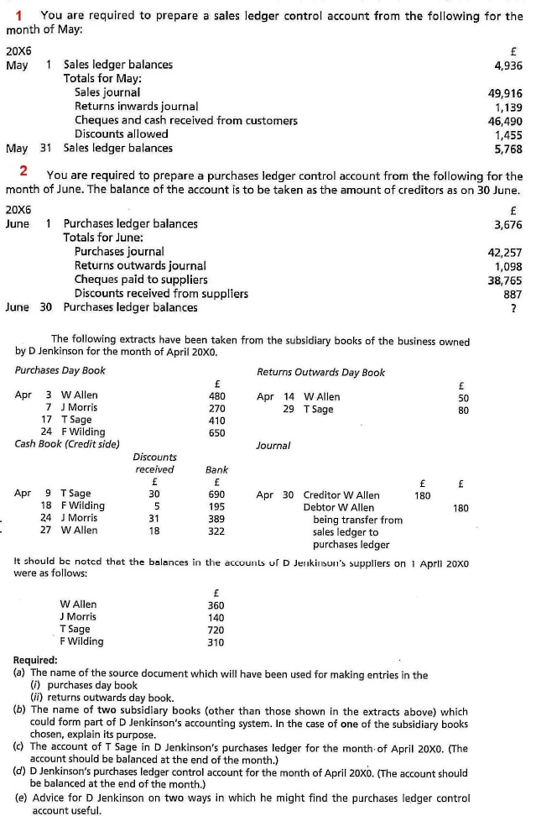

**BANK RECONCILIATION STATEMENTS**